**Work Force Management**

Using Workforce Force Management system Project application Human resource management can easily manage to request lock between employees and inform manager using the request system.

* Using dot net core MVC project,create web application.
* API calls are done API projects.
* Login in implemented by Token authentication.
* Data is processed dynamically.

**Back End:**

SQL Tables:

The below mentioned tables are used for maintaining the employee datas.

1. Employee Table

CREATE TABLE [dbo].[Employee](

[EmployeeId] [int] IDENTITY(1,1) NOT NULL,

[Name] [varchar](50) NOT NULL,

[Status] [varchar](50) NOT NULL,

[Manager] [varchar](30) NULL,

[Wfm_manager] [varchar](30) NULL,

[Email] [varchar](70) NULL,

[Lockstatus] [varchar](30) NULL,

[Experience] decimal(5,0) NULL,

[Profile_Id] int NULL

)

1. Skill Table

CREATE TABLE [dbo].[Skills](

[Skillid] decimal(5,0) NOT NULL Primary key,

[Name] [varchar](30) NOT NULL

)

1. SkillMap

CREATE TABLE [dbo].[SkillMap](

[Employeeid] int NULL,

[Skillid] decimal(5,0) NULL,

CONSTRAINT FK_Employeeid FOREIGN KEY (Employeeid)

REFERENCES Employee(Employeeid)

CONSTRAINT FK_Skillid FOREIGN KEY (Skillid)

REFERENCES Skills(Skillid)

)

1. User

CREATE TABLE [dbo].[Users](

[Username] [varchar](30) NOT NULL Primary key,

[Password] [varchar](30) NOT NULL,

[Name] [varchar](30) NOT NULL,

[Role] [varchar](30) NOT NULL,

[Email] [varchar](70) NULL

)

1. SoftLock

CREATE TABLE [dbo].[Softlock](

[EmployeeId] [int] NULL,

[Manager] [varchar](30) NULL,

[ReqDate] [datetime] NULL,

[Status] [varchar](50) NULL,

[LastUpdated] [datetime] NULL,

[LockId] [int] NOT NULL,

[RequestMsg] [varchar](100) NULL,

[WfmRemark] [varchar](100) NULL,

[ManagerStatus] [varchar](30) NULL,

[ManagerStatusComment] [varchar](50) NULL,

[MgrLastUpdate] [datetime] NULL

)

**Front End:**

* Login Page

In MVC, Authentication is a feature in MVC that helps in making the website highly secure and safe. Authentication is the process of confirming or validating the user's identity if the user who is trying to access the web page or web application is a genuine user or not.

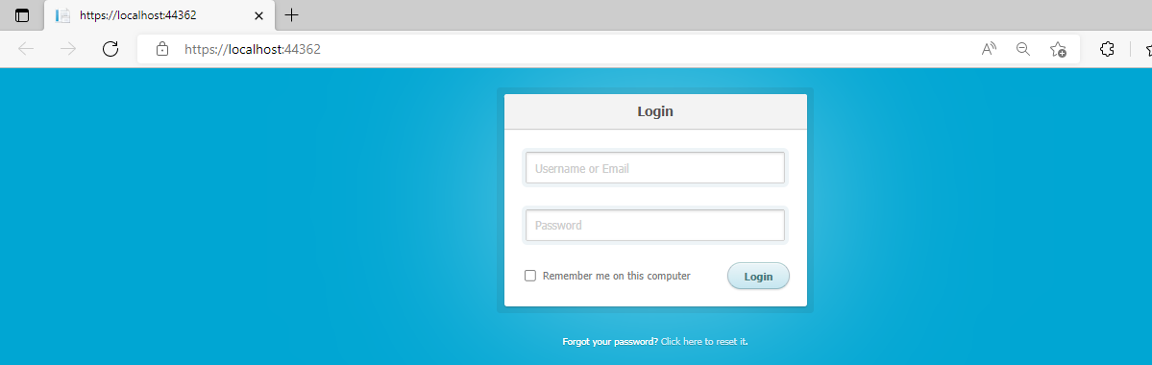

* Manager View

This page will display the details of employees with experience and corresponding skills.

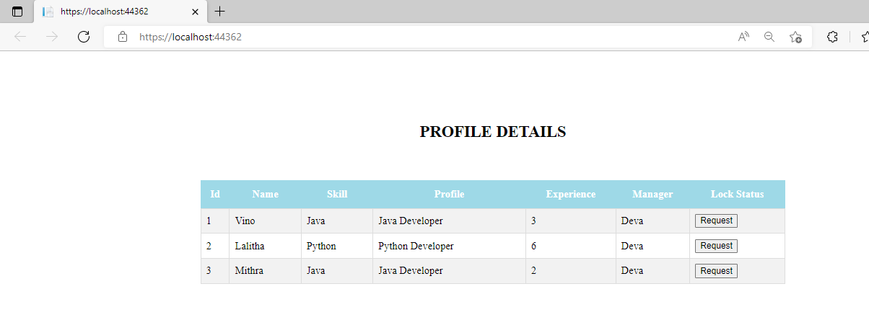

* Request Confirmation

In this page,manager confirm the request for corresponding employee with details.

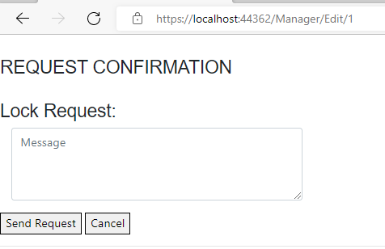

* WFM Manager

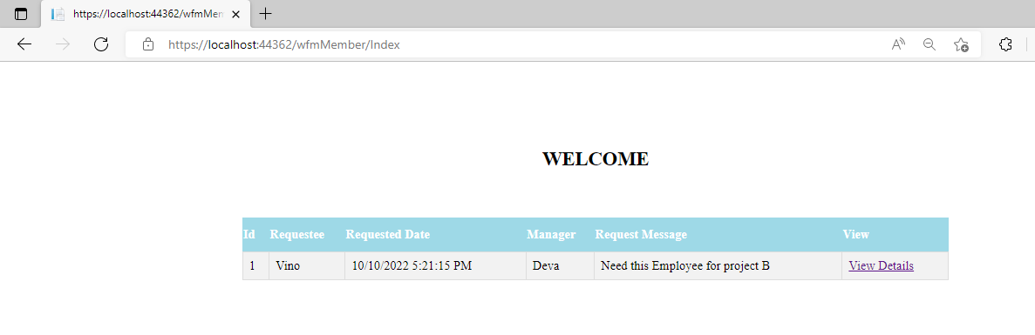

By clicking the status dropdown,WFM member can select the appropriate options.

